

Administrator guide

## Version history

|  |  |  |  |  |
| --- | --- | --- | --- | --- |
| Name | Date | Version | Reason | Comment |
| Christian Andersson | 2019-09-03 | 0.1 | Initial version | - |
| Christian Andersson | 2019-09-13 | 1.0 | Reworked to admin guide | Added inventory, Software installation and index. |
|  |  |  |  |  |
|  |  |  |  |  |

Contents

Version history 2

Remote control 3

Inventory 6

Software installation 9

## Remote control

1. Go to <https://mes-mgmt/> and log in with your z-account.  
   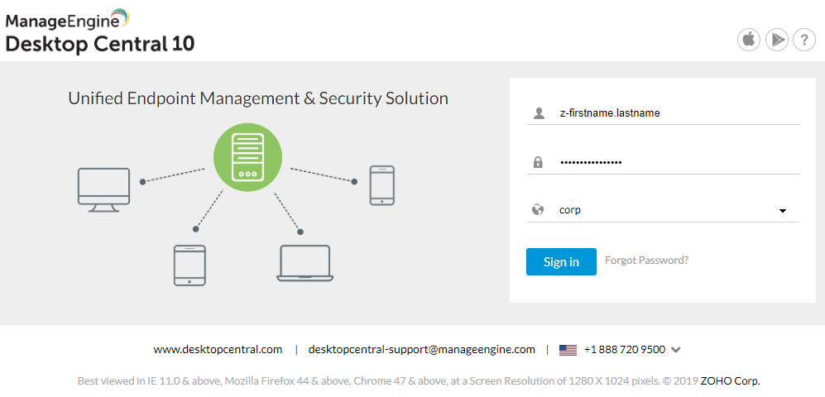
2. Click on Tools.  
   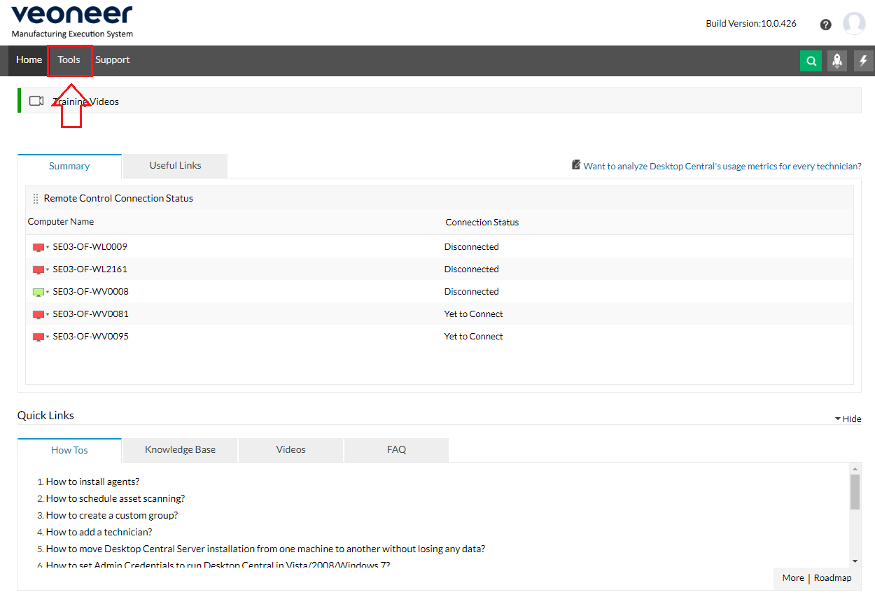
3. Open Remote Control.  
   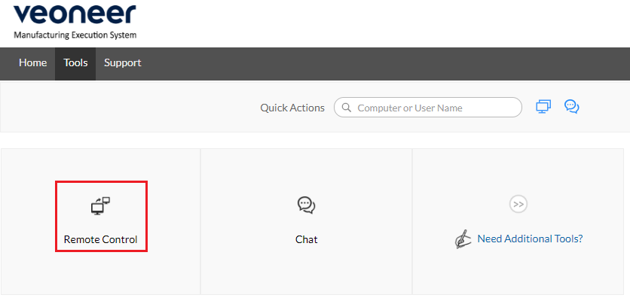
4. Find the client you want to control, then press connect. The green or red display will indicate if the client is online or not. If it’s red you will not be able to connect.  
   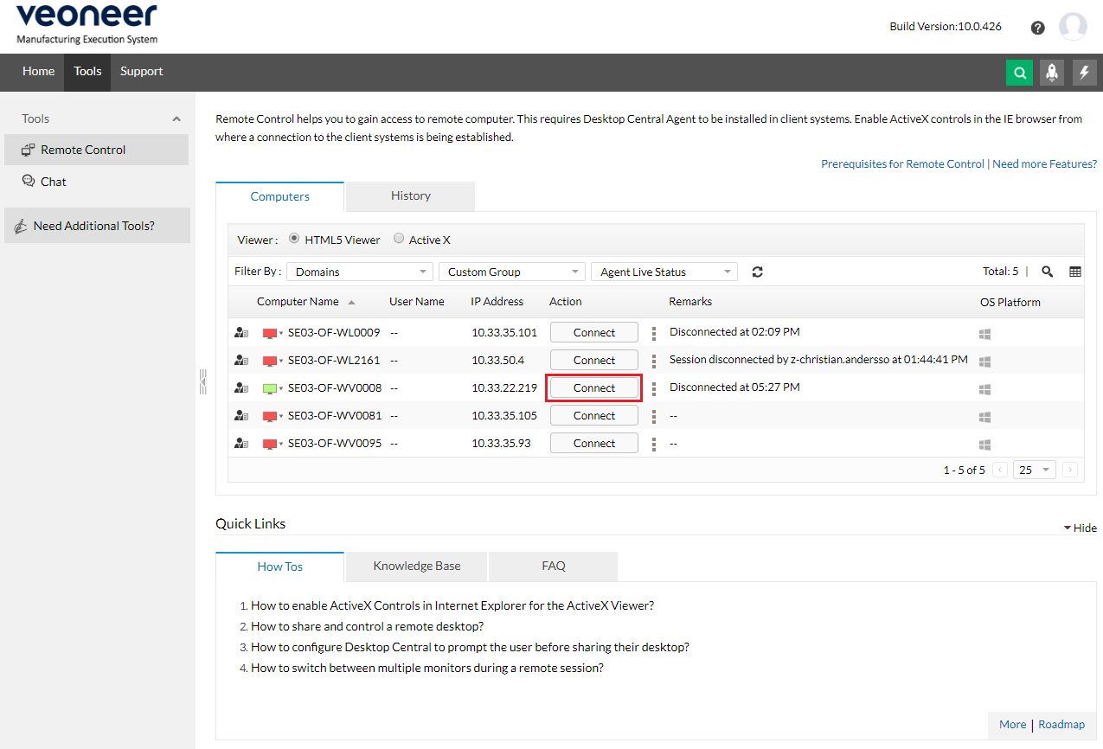
5. Enter a reason for why you are connecting to the client. Please note that your reason will be logged.  
   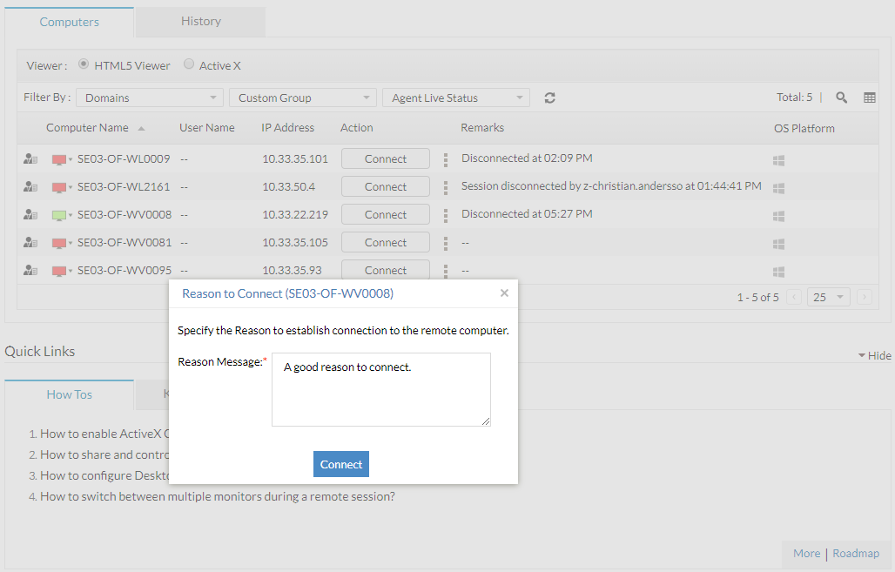
6. You are now connected and can remote control the client. Close the remote-control window to disconnect from the session.  
   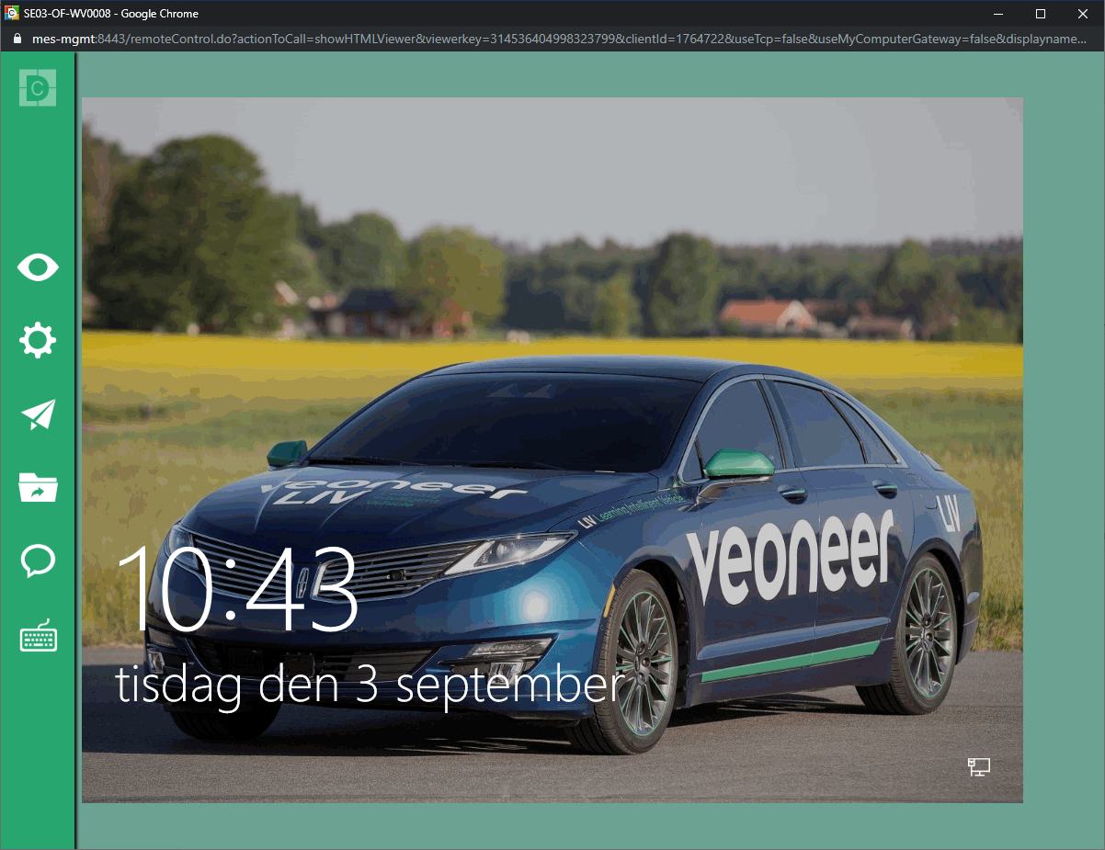

## Inventory

1. Go to <https://mes-mgmt/> and log in with your z-account.  
   
2. Click on Inventory  
   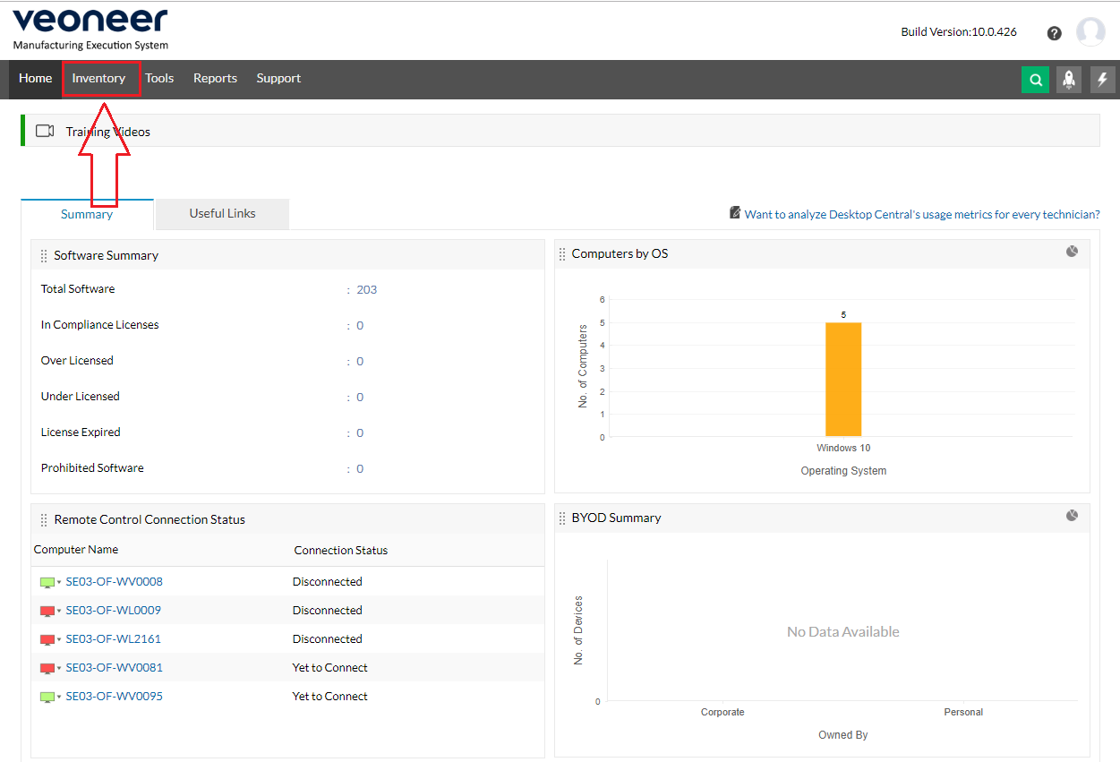
3. From the inventory page you can see different information about the clients on your site.  
   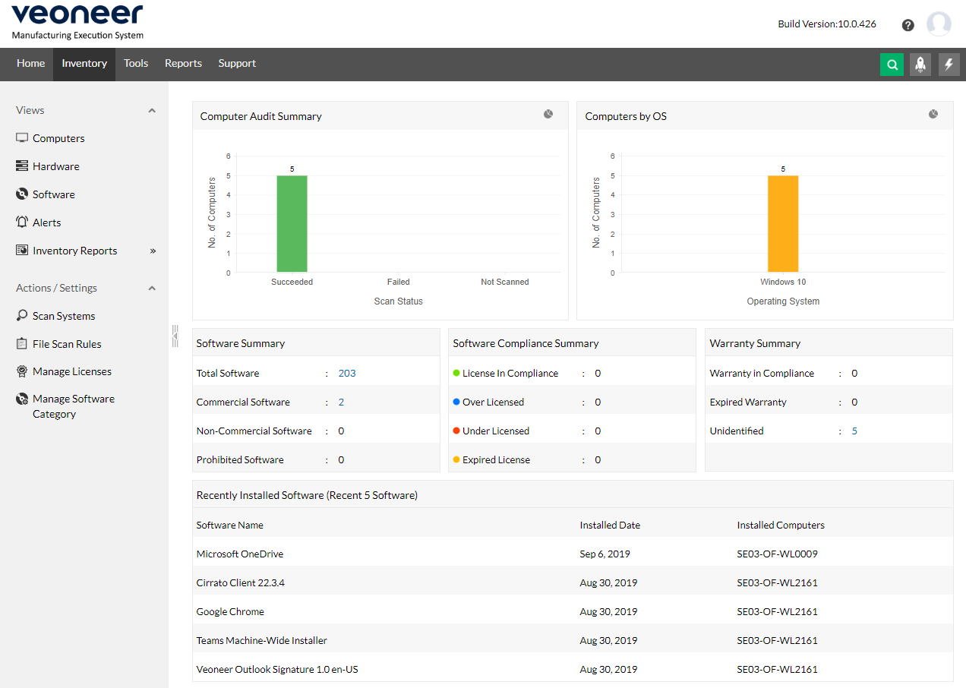
4. If you open Computers you will see a complete list of all the inventoried clients. Click on a computer name to explore more.  
   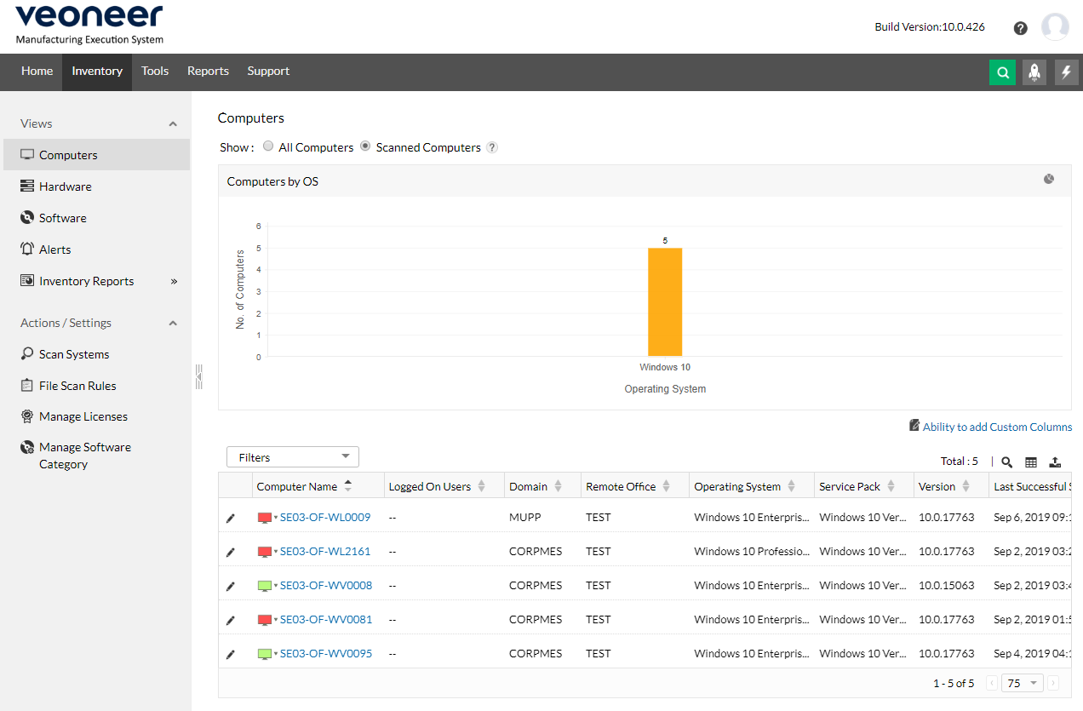

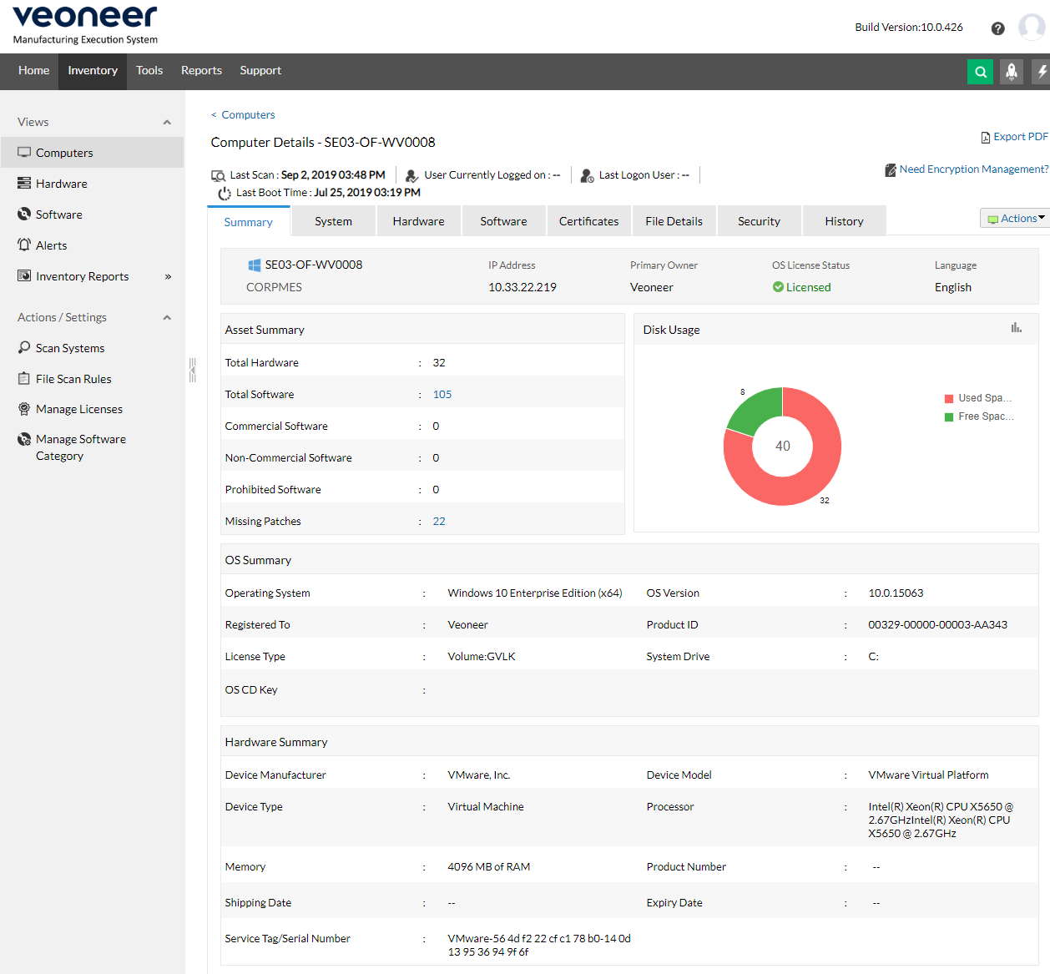

## Software installation

Limited amounts of software can be deployed via MEDC based on the MES demands. Normally we can import packages from our SCCM if more is needed.

To see what packages that are imported to our MEDC search for D-MES-Software in the CORPMES.INT domain or open the OU CentralResources\Function_Groups.

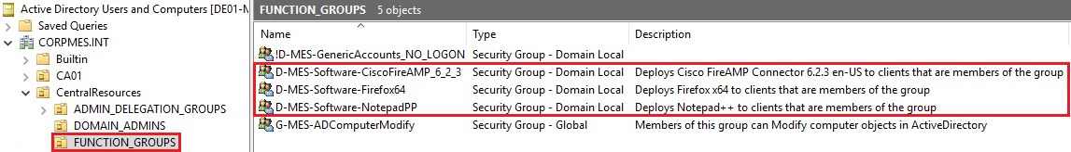

These groups are central and clients can NOT be added directly to these groups.

If a site wants access to a software, they contact the client team via a generic request. When it’s approved the client team will create a site-specific group in the site’s GROUPS\FUNCTION OU that the clients can be added to.

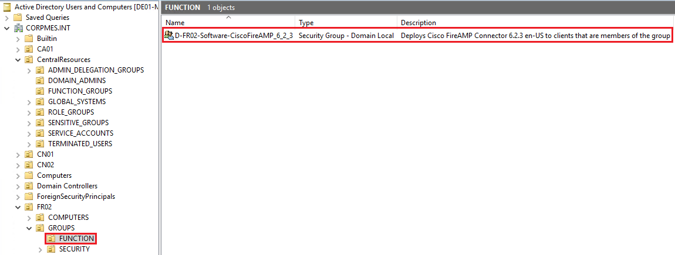

When a client is added to the group it will take up to 90 minutes until the software installs.

If you wish to force a client to install quicker you can log in on the client, right click on the MEDC icon and select Apply Configurations.

